DATA-DRIVEN CUSTOMER SEGMENTATION AND PRODUCT RECOMMENDATION SYSTEM FOR SMEs

EMEKA HILARY NWOSU
STUDENT ID: 20023332

DEPARTMENT OF COMPUTER SCIENCE AND TECHNOLOGY
YOUR FACULTY
ULSTER UNIVERSITY
BIRMINGHAM CITY, ENGLAND

MONTH, 2026

SUPERVISOR: MICHAEL AJAO-OLARINOYE

Acknowledgement
Give Thanks to people helping

Abstract
Small and medium-sized enterprises (SMEs) in e-commerce routinely collect transactional data, yet most lack the analytical infrastructure to convert that data into customer insight, personalised marketing, or effective product recommendations. While large technology companies use advanced segmentation and recommendation engines to retain customers and drive sales, equivalent capability remains largely out of reach for SMEs because of cost, technical complexity, and limited in-house expertise. This study addresses that gap by designing and evaluating a data-driven customer segmentation and product recommendation system that is deliberately scoped to the resource constraints of SME e-commerce businesses, using the UCI Online Retail dataset, a real-world transactional dataset from a UK-based online retailer, as the empirical basis for the work.
The dataset is first cleaned and preprocessed, including the removal of cancelled transactions, invalid quantities and prices, and the handling of missing customer identifiers, before customer-level features such as Recency, Frequency, and Monetary (RFM) value, total spend, and order count are engineered. Customer segmentation is then performed by combining RFM analysis with K-Means and hierarchical clustering, with the resulting segments compared using silhouette score, Davies–Bouldin index, and business interpretability. A product recommendation component is developed using association rule mining and item-based collaborative filtering, benchmarked against a simple popularity baseline, and evaluated using support, confidence, lift, and precision and recall at K. Unlike much of the existing literature, which treats segmentation and recommendation as separate problems and is typically validated on large-enterprise platforms, this study integrates both components into a single pipeline applied to the same dataset and explicitly considers the practical constraints under which an SME would adopt such a system.
The expected outcome is a reproducible, low-cost analytics pipeline that allows an SME to move from raw transaction logs to interpretable customer segments and actionable product recommendations, supporting practical decisions around marketing, cross-selling, and customer retention. The study also considers the data protection and ethical implications of customer analytics, restricting its analysis to purchasing behaviour rather than demographic or other sensitive attributes. The findings are expected to provide SME e-commerce businesses with practical, evidence-based guidance on which combination of clustering and recommendation techniques is most suitable for their scale of operation, while contributing to the broader literature on customer analytics by addressing a context, the SME, that has received comparatively little attention relative to large-enterprise applications.
Keywords— Customer Segmentation; SME E-Commerce; RFM Analysis; K-Means Clustering; Hierarchical Clustering; Product Recommendation; Association Rule Mining; Collaborative Filtering

Table of Contents
Acknowledgement 2
Abstract 3
Table of Contents 4
Chapter One 5
1.1. Introduction 5
1.2. Statement of the Problem 5
1.3. Research Aim and Objectives 6
1.4. Research Questions 6
1.5. Novelty of Research 7
1.6. Ethical Concerns 7
References 9
Appendix 10

Chapter 1

Introduction
Small and medium sized businesses (SMEs) constitute a significant portion of the global economy and the digital transformation has made it possible for even the smallest retailers to now have the means to offer e-commerce services. Each purchase from an online store, made by an SME, leaves a digital footprint, in the form of which, how often, how much and in which combinations. Although this transactional data is plentiful, most small businesses do not have the analytical tools to convert transactional data into actionable insights. SMEs still experience resource constraints, lack of technical expertise and increasingly more complex business environments which are making it more challenging for SMEs to manage data-driven processes as large businesses do (Vu et al., 2025). This makes SMEs an important part of the economy, and the present-day business world is rapidly shifting towards leveraging cutting-edge technological advancements that enable SMEs to comprehend and sustain their customers, as compared to large technology firms, which can utilize advanced analytics and personalization to successfully understand and retain customers (Gupta, Fernández-Crehuet, & Gupta, 2022).
One of the oldest methods of turning the raw transaction data into business intelligence is customer segmentation. The segmentation of customers into groups with common purchasing patterns to allow the marketing, retention and services to be directed to each group rather than applied to the whole population. The Recency, Frequency, and Monetary (RFM) segmentation model is among the most popular segmentation models used, as it is simple and grounded in observable buying behavior. The silhouette index and Calinski–Harabasz index are used to differentiate between various clustering methods by analyzing the transactional data set, with RFM often showing superior results compared to hierarchical clustering on such data sets in terms of silhouette index and Calinski–Harabasz index (Wong, Tong, & Haw, 2024).
In addition to segmentation, recommendation systems solve a complimentary problem: given the understanding of the customers, what should the next product/service be pushed to the customer? Sarwar, Karypis, Konstan, and Riedl (2001) showed that collaborative filtering recommendations could be made efficiently by analyzing the item relationships, as well as the user relationships, a method that is used in many of today's e-commerce systems to recommend items to users in large catalogues and is the basis for much of the current personalization. Association rule mining is another method proposed by Agrawal, Imieliński and Swami (1993), which is a very efficient method of finding the relationships between items purchased together in large transaction databases. Both of these techniques are still basic building blocks of product recommendation design and are directly applicable to the type of invoice level transactional data present in an online retail data set.
The research in this context, thus, explores the possibilities of using transactional data from an online retail business similar to an SME to construct a customer segmentation and product recommendation system. The study employs UCI Online Retail dataset, a real world transactional dataset from a UK based online retailer, to develop and test RFM based segmentation, clustering and recommendation models specifically targeted for the resource and complexity constraints of a typical SME.

Statement of the Problem
A lot of SME e-commerce businesses are collecting transaction data as a by-product of their normal trading but they lack the tools, skills or budget to make sense of this data or make business decisions based on it. While there is well-developed analytics and recommendations technology in large corporations, it can be economically unfeasible for smaller companies due to the cost, technology, and lack of in-house expertise. This disparity creates some common issues for SMEs:
The purchasing behaviour is not analysed systematically and customers are not provided with customised marketing and product recommendations.
High value or at risk customers are hard to identify within a non-segmented customer base for businesses. Where there are product recommendations they are usually very general ones and not based on actual co-purchasing events.
A poor retention rate and repeat purchase percentage is due to lack of focused marketing efforts on the most likely segments to respond. Although segmentation and recommendation have been extensively studied in academic and industry research and are well-established in large enterprise or e-commerce giant data sets (Sarwar et al., 2001; Linden, Smith, & York, 2003), there is a lack of research addressing the situation in which an SME with a much smaller number of transactions, technical personnel, and budget can implement similar techniques in a realistic and repeatable manner. This study attempts to answer this question as the problem it seeks to solve is the lack of a low cost, repeatable analytics pipeline for an SME to go from raw logs of transactions to discoverable segments of customers and actionable product recommendations.

Research Aim and Objectives
Aim: The aim of this study is to design and evaluate a data-driven customer segmentation and product recommendation system for SME e-commerce companies, using the UCI Online Retail transaction dataset as a case study.

Objectives
The specific objectives of the study are to:
- Collect and preprocess the UCI Online Retail transaction dataset, including the removal of cancelled transactions, invalid quantities and prices, and the handling of missing customer identifiers;
- Engineer customer-level features, including Recency, Frequency, and Monetary (RFM) values, total spend, and order counts, to support segmentation;
- Perform customer segmentation using RFM analysis in combination with K-Means and hierarchical clustering, and compare the resulting segments using silhouette score and Davies–Bouldin index;
- Design and implement a product recommendation component using association rule mining and item-based collaborative filtering, benchmarked against a simple popularity baseline;
- Evaluate the recommendation models using support, confidence, lift, and precision/recall at K; and
- Discuss how the resulting segments and recommendations could practically support SME e-commerce decision-making, including marketing, cross-selling, and customer retention.

Research Questions
The study seeks to answer the following research questions:
- How can transactional business data be transformed into actionable insights for SMEs through Business Intelligence techniques?
- Which machine learning models provide the most accurate predictions for sales forecasting within SME environments?
- How effectively can customer segmentation techniques identify meaningful customer groups and purchasing behaviors?
- How can an AI-driven Business Intelligence dashboard improve decision-making processes and operational performance in SMEs?
- To what extent can predictive analytics support proactive business planning and resource optimization for SMEs?

Novelty of Research
A substantial body of prior work has applied RFM analysis and clustering to customer segmentation in e-commerce, and a separate body of work has applied collaborative filtering and association rule mining to product recommendation. However, much of this literature treats segmentation and recommendation as independent problems, and a large proportion of it is validated on enterprise-scale platforms or proprietary datasets that are not representative of SME operating conditions (Sarwar et al., 2001; Linden et al., 2003). Several recent segmentation studies, for instance, extend the RFM model with additional behavioral dimensions or compare multiple clustering algorithms on transactional data (Wong, Tong, & Haw, 2024), but they generally stop at segmentation and do not connect the resulting segments to a downstream recommendation mechanism.
The novelty of this research lies in three areas. First, it integrates customer segmentation and product recommendation into a single, end-to-end pipeline applied to the same transaction dataset, rather than treating the two as separate research problems, so that the segments produced by the clustering stage can directly inform and be evaluated against the recommendation stage. Second, it deliberately scopes the methodology, tool choices, and evaluation criteria to the constraints of SMEs, an underexplored context relative to the large-enterprise focus of most published segmentation and recommendation research, addressing a gap explicitly identified in studies of SME technology adoption (Vu et al., 2025). Third, it benchmarks more than one clustering technique (K-Means and hierarchical clustering) and more than one recommendation technique (association rule mining and item-based collaborative filtering) against a simple popularity baseline within the same study, producing a comparative evidence base for which combination of techniques is most practical for an SME e-commerce business, rather than presenting a single algorithm in isolation.

Ethical Concerns
Although the UCI Online Retail dataset used in this study is anonymized and does not contain personally identifiable contact details such as names, addresses, or payment information, the broader practice of customer segmentation and personalized recommendation raises ethical considerations that this research acknowledges and addresses.
First, data protection and privacy remain central concerns whenever customer transaction data is analyzed. Regulatory frameworks such as the General Data Protection Regulation (GDPR) require organizations to adapt their personalization strategies to prioritize data protection, transparency, and customer consent when processing personal data (Okunola, 2025). Although this study uses an already anonymized, publicly available dataset for academic purposes, any real-world deployment of the resulting system by an SME would need to apply similar principles, such as pseudonymization and anonymization, to maintain personalization capability while minimizing the processing of personal data (Okunola, 2025).
Second, there is an ethical dimension to how customer segments are used once they are created. Segmentation that identifies “high-value” or “low-value” customers could, if used carelessly, lead to discriminatory pricing or exclusion of certain customer groups from offers and services. This study mitigates that risk by restricting its segmentation and recommendation logic strictly to purchasing behavior captured in the transaction data (recency, frequency, monetary value, and item co-occurrence), rather than to demographic or other sensitive personal attributes.
A further ethical consideration specific to this research context is that SMEs adopting new analytics technologies often do so with limited technical expertise and without the structured evaluation processes available to larger organizations (Gupta, Fernández-Crehuet, & Gupta, 2022). This raises a responsibility on the part of researchers developing SME-facing analytics tools to keep the methodology transparent, interpretable, and well documented, so that an SME adopting the resulting system can reasonably understand and validate what it does before relying on it for marketing or customer decisions.
Third, the study observes academic and data-use integrity by relying solely on the publicly available UCI Online Retail dataset under its stated terms of use, and by ensuring that no attempt is made to re-identify individual customers from the anonymized customer identifiers present in the data. All code, analysis, and reported results will be made available through a version-controlled repository to support reproducibility and transparency in line with good research practice.

CHAPTER 2

2.1 Literature review
This chapter summarizes the current state of knowledge regarding the three main aspects of this study: Customer Segmentation in e-commerce, Product Recommendation Systems, and Technology Adoption in Small and Medium Scale Enterprises (SMEs). The review also analyzes the dataset used to support the empirical aspects of the research and reviews the evaluation metrics employed to evaluate the performance of the segmentation and recommendation models. This review aims at providing the theoretical underpinning of this study and at revealing the gaps in the literature that the study aims at addressing.

2.2 Customer Segmentation in E-Commerce
Segmentation of customers is the process of dividing the market into customer segments and then developing marketing strategies, prices, and services for them separately from the rest of the market. One of the most tractable and commercially valuable applications of data analytics that have become commonplace in e-commerce is segmentation based on purchase behavior, where businesses meet customers solely online and where customer transaction records are generated automatically (Dritsas & Trigka, 2025). Consumer trust and the ethical use of consumers' data have been raised alongside the adoption of BI and AI-based personalization techniques, which are more and more used to achieve fine-grained customer segmentation and individualized recommendations(Abidar et al., 2024).
The case study by Chen, Sain and Guo (2012) describes their work in developing a small UK-based online retailer's ability to use customer transaction data to segment their customers for more effective customer-centric marketing through RFM analysis and data mining techniques. This is not only the original analysis of the data set used for the present research, it is also a major example of how data mining can be used for the segmentation problem of a small online retailer with no extensive technical skills. The authors concluded that the RFM segmentation yielded meaningful customer segments which could be directly used to plan marketing activities, setting the groundwork for future research using the same data.
Recent systematic reviews have also demonstrated that customer segmentation through machine learning (ML) has emerged as the most common method in commercial applications, where researchers use various algorithms and methods to measure the effectiveness of their segmentation (Abidar et al., 2024). A detailed analysis of customer segmentation methods using ecommerce data revealed that, irrespective of the algorithm, the ability to distinguish between statistically different customer segments was far superior with algorithmic methods as compared to manual or rule-based methods, and that the type of features used to create a clustering model was almost as significant as the algorithm itself. Among this expanding body of work, RFM analysis and clustering are notably significant due to their interpretability and to the fact that they are based directly on transactional data easily accessible to SME practitioners who have to interpret and act on the segments that are provided without the help of specialists in data science

2.3 RFM Analysis
Hughes (1994) proposed a practical solution to find out the most valuable customers in the context of database marketing: Recency, Frequency, and Monetary (RFM). The framework assigns a score to each customer based on three areas directly connected to their purchase history: Recency (how long since the customer made a purchase); Frequency (how many purchases the customer has made over a certain period of time); Monetary value (the total amount purchased by the customer over time). A customer with high scores across all three dimensions is viewed as the most valuable customer; one with low scores on recency and frequency is deemed to be in jeopardy of losing business.
The durability of RFM analysis in business analytics has been proved by several reasons: it is not very complicated to compute, it requires only transactional data, and its results are easily understood by non-technical business users. Tabianan, Velu, and Ravi (2022) found that customer segments created using K-Means clustering on RFM-scored customer data have business interpretations that are clear and actionable, for example, within the customer segments there are loyal customers, potential churn risks, or high-value recent customers. When they studied a real world customer purchase data set, they found that using RFM scoring & K-Means clustering results in segments that are more cohesive within themselves and are more useful for business purposes when compared to just one of the two techniques.
In recent literature, the shortcomings of the conventional 3-D RFM model have also been studied. Madanchian (2024) stated that conventional RFM ignores dimensions like channel preference, basket depth and the regularity of the purchase intervals, and suggested an extended RFM framework that incorporates additional behavioural dimensions besides the existing dimensions of recency, frequency, and monetary value. In the same vein, other researchers have incorporated the age or product-category segmentation to get more discriminative segments in certain retail settings. In this study, however, we aim to make the system practicable to be replicated by SMEs with less data infrastructure, and thus we rely on a standard 3D RFM system, as done in the original analysis of the UCI Online Retail data set by Chen et al. (2012).

2.4 Clustering Algorithms for Customer Segmentation

2.4.1 K-Means Clustering
An iterative partitioning algorithm using K-Means is used to partition a dataset into k clusters which minimizes the sum of squared distances between the data point and its cluster centroid. It is widely used in customer segmentation due to its computational efficiency, ability to scale up to large data sets and simplicity of implementation (Tabianan, Velu, & Ravi, 2022). In the segmentation scenario based on RFM, K-Means assigns each customer to the cluster with the closest centroid in the RFM space resulting clusters which can be characterized by the average value of the RFM measures of a cluster.
The main drawback of the K-Means method is that the number of clusters (K) has to be given. This is usually done with auxiliary methods: plotting the within-cluster sum of squares against k and finding the point at which the difference between the clusters starts to become smaller; silhouette analysis, which determines the extent to which each point is contained in its own cluster compared to others (Rousseeuw, 1987). When testing various clustering algorithms on UK retail customer data, it was found that the silhouette scores for the K-Means algorithms were reasonably high (0.64), while other algorithms such as Gaussian mixture models and agglomerative failed on the same data (Ezugwu et al., 2024), highlighting the need for multiple algorithms to be compared when evaluating their clustering performance over others.
K-Means is also sensitive to the initialisations: the same random initialization of the centroids can give different cluster assignments. This is usually treated by repeating the algorithm a few times with different random seeds, and picking the one that leads to the lowest total wcv, as is done by default in libraries like Scikit-learn.

2.4.2 Hierarchical Clustering
Hierarchical clustering constructs a 'tree' of clusters by either merging (agglomerative) or splitting (divisive) data points or clusters in an iterative manner to generate a hierarchical structure known as a dendrogram that enables the number of clusters to be determined by the analyst after the algorithm has been executed. The most widely used variation in customer segmentation research is agglomerative hierarchical clustering, in which individual data points are sequentially grouped into clusters based on some linkage measure (e.g., Ward's minimum variance).
Among the algorithms, the study demonstrated that hierarchical clustering was superior in terms of silhouette score and Davies–Bouldin index with the added benefit of not having to specify the number of clusters for the data set when tested on a customer data set (International Research Journal of Modernization in Engineering, Technology and Science [IRJMETS], 2025). The same study highlighted that the dendrogram generated by the hierarchical clustering method will provide better visualisation of the relationship between the customer groups, which can be useful when communicating the findings of the segmentation to non-technical SME stakeholders.
The main disadvantage of hierarchical clustering is that it can be very time consuming. The algorithm is quadratic in size of the data set, as it needs to calculate the distance between every pair of data points, which is less desirable for very large transaction databases. After preprocessing, there are about 4000 unique customers in the UCI Online Retail dataset, making hierarchical clustering a viable option.

2.4.3 Comparison and Selection of Clustering Approaches
This is an introduction to some clustering approaches. It is not so easy to determine customer segmentation on the basis of the performance of the two algorithms K-Means and hierarchical clustering. Wong, Tong and Haw (2024) aimed to assess the performance of different clustering algorithms on e-commerce customer data by applying multiple evaluation measures which includes silhouette score and the Calinski–Harabasz index. They found that the performance of K-Means and agglomerative clustering varied with the data set and no particular algorithm was significantly better across the evaluation measures. This discovery encourages the comparative method used in this research, which involves using the same customer information based on RFM scores and the same metrics of comparison to decide the results of the two algorithms.

2.5 Cluster Evaluation Metrics
Since clustering is an unsupervised task, there is no ground-truth set of labels to use for validation of the obtained clusters; therefore, some internal evaluation metrics are applied in assessing the quality of the obtained clusters. The Davies–Bouldin index and silhouette score are the two most popular internal metrics for customer segmentation research.

2.5.1 Silhouette Score
Rousseeuw (1987) has suggested a silhouette score to quantify the similarity of each data point to its own cluster and to the nearest cluster in the neighborhood. The silhouette value s(i) for each data point i is defined as (b(i) - a(i))/max(a(i), b(i)), where a(i) is the average distance between data point i and other data points in its own cluster, and b(i) is the average distance between data point i and the closest data point that does not belong to its own cluster. The score is on a scale of −1 to +1, with +1 being the best match of the data points to their own cluster and separation from other clusters. Scores close to zero are signs that the clusters overlap, negative scores are a clue that a point could have been miscoded.
Customer segmentation studies typically use silhouette scores >0.5 as evidence of a significant cluster structure. In this study the silhouette score is employed to both select the number of clusters k for the K-Means step and to compare K-Means and hierarchical clustering outputs and measure the relative quality of these.

2.5.2 Davies–Bouldin Index
The Davies-Bouldin index, proposed by Davies and Bouldin (1979), is based on the similarity between each cluster and the most similar cluster, which is determined based on the ratio of within-cluster scatter to between-cluster separation. The Davies–Bouldin index is better because it has a lower value, the closer to zero the more perfect the clustering result. The index is especially helpful because it punishes solutions where clusters are dispersed and are relatively close, and such clusters would yield segments hard to discern and useful for business.
Research that has used both metrics to segment customer data sets has shown that in general, the different metrics seem to rank the various clustering solutions in the same order, but this ordering can differ when the clusters are highly variable in shape or density. Combining both metrics, as done in this study, gives a more complete picture of the quality of a cluster than either of the two metrics taken alone.

2.6 Product Recommendation Systems
Recommendation systems are software programs that use information or products to recommend those that are more likely to be relevant to a certain user, depending on the user's past actions, the actions of similar users, or the characteristics of the products that the user has interacted with(Dritsas & Trigka, 2025). Recommendation systems are one of the most important tools in e-commerce for providing personalised shopping experiences and have been proven to drive product discovery, basket size and retention. Sarwar, Karypis, Konstan, and Riedl (2001) showed that recommendations can be efficiently generated by computing similarities between items, in contrast to computing similarities between users, which has greater scalability properties for the number of users and less cold-start problem for new users than user-based collaborative filtering.

2.6.1 Association Rule Mining
Association rule mining is a technique used to find association among items that occur together in transactions frequently. The Apriori algorithm is the first efficient algorithm for association rule mining from large transaction databases, introduced by Agrawal, Imieliński, and Swami (1993), which uses the antimonotonicity property of the support measure: If an itemset is frequent, all of its subsets must also be frequent, thereby allowing the search space to be pruned systematically. FP-Growth algorithm further enhanced Apriori by reducing number of database scans (by organizing the transaction database in a frequent-pattern tree structure) and also reducing computation time on large datasets (Sreelakshmi, Padhy, & Senapaty, 2025).
The results of association rule mining are a collection of rules such as “if a customer buys item X, then he is likely to buy item Y”, measured by three criteria: support, which is the percentage of transactions that have both items X and Y; confidence, which is the percentage of transactions that contain X and also contain Y; lift, which is the ratio of support to the percentage of transactions containing X and Y that are expected by chance. If the lift value exceeds one, the two items occur together more often than you would expect, thus making the rule potentially useful for cross-selling recommendations (Polipapers, 2024). Association rules, which are based on past transactions, give an immediate output that can be taken directly to the customer: products that are often bought together can be packaged together, displayed side by side in the online store, etc. or even recommended to the user in personalized e-mail.
The two algorithms, Apriori and FP-Growth, were recently compared in a real-world application to e-commerce transactional data, where it was found that both algorithms generated the same sets of rules, but FP-Growth had significantly less computation time, particularly for large transaction databases. In the current study, both algorithms are tested to enable a straightforward comparison between output of the algorithms and the UCI Online Retail data.

2.6.2 Item-Based Collaborative Filtering
The collaborative filtering recommendation approach is one that provides suggestions by using the properties of many users, not individual items. According to Sarwar et al. (2001), item-based collaborative filtering generates a similarity matrix of the items by analyzing the ratings or purchase data of the users who have rated or purchased the items. The algorithm will find items that are similar to the items the user has already bought and sort them by the likelihood that they will be relevant to the user.
A comparison of several collaborative filtering variants showed that, for moderate sized data sets, memory based methods like item-based K-nearest neighbours are competitive to the more complicated model based methods for some ranking metrics like precision and recall at K (Khelloufi & Laallam, 2025). A parallel study related to the use of item-based collaborative filtering against content-based methods and neural network models with a large e-commerce data set revealed that, although the content-based methods had better performance than the item-based method, the latter was easily interpretable and easily implemented (Feng et al., 2024). These properties render item-based collaborative filtering to be a suitable approach for an SME-based system where interpretability and implementability are critical, as well as the raw recommendation's accuracy.

2.6.3 Popularity Baseline
The most basic recommendation system is the popularity baselines: recommend the most popular products in the dataset to all users, irrespective of their buying history. A popularity baseline is merely a value that is not realistic but serves a valuable methodological purpose. It provides a lower limit of performance for any useful recommendation system, for if a more intricate algorithm cannot do better than a list of the most popular products, there is little evidence that it is learning about real user-item affinity as opposed to just aggregate purchase distribution. It is common to include a baseline of popularity in the assessment of recommendation systems (Khelloufi & Laallam, 2025).

2.7 Recommendation Evaluation Metrics
There are several metrics used to measure the effectiveness of a recommender system, which measures various aspects of a recommender system's performance. Precision at K, recall at K, support, confidence and lift are the metrics used in this study.
Precision at K (Precision@K) is the ratio of the number of relevant items in the top K results by the total number of items that can be viewed in the top K results. Recall at K (Recall@K) indicates the percentage of all the relevant items presented to the user that are contained in the top K recommendations (Khelloufi & Laallam, 2025). Both are based on a train/test split of the transaction data, where a portion of the known purchases are removed from the model and serve as a ground truth to compare its recommendations with. In association rule mining, the chief evaluation metrics that directly focus on the statistical power and significance of every rule found are support, confidence and lift (Agrawal et al., 1993).

2.8 The UCI Online Retail Dataset
This UCI Online Retail dataset was made available to the UCI Machine Learning Repository by Chen (2015), and includes all transactions made by an online UK-based non-store retailer selling unique all-occasion gifts, many of whose customers were wholesalers, from 1st December 2010 to 9th December 2011. The data consists of 541,909 transactions, each with eight fields: invoice, stock code, product description, quantity, invoice date, unit price, customer and country. It has been becoming one of the most popular publicly released transaction datasets used in the customer segmentation and recommendation systems literature and has been used as a benchmark in many published research papers (Ezugwu et al., 2024; Wong, Tong, & Haw, 2024).
The data comes with a number of pre-processing limitations typical of SME transaction data: Some rows are missing customer identifiers (around 25% of data) and some transactions are cancelled (marked by the letter “C” in the invoice number) and have negative quantity (returned items) or zero or negative unit price (admin adjustments). The appropriate handling of such issues is a very important aspect of research, as the quality of output from segmentation and recommendation depends directly on the quality of the transaction data which is used to build such outputs. In the present study, the strategy used is similar to those used in previous published analyses of the data, in that cancelled transactions were excluded (Chen, Sain, & Guo, 2012), and the rows with missing customer identifiers and the quantities and prices were not positive were filtered out.

2.9 Customer Analytics in the SME Context
SMEs hold a unique place in the customer analytics world. Then on the other hand, they create transaction data on a regular basis during their ecommerce operations and the data has the same types of purchasing signals as the large retailers use to personalize marketing and recommendations. SMEs, however, tend to not have the in-house data science ability and the budget for enterprise level data analytics platforms and the structured data governance processes that enable large firms to systematically leverage these signals (Justy et al., 2023). The systematic literature review of big data analytics adoption in SMEs revealed that financial resources, lack of digital skills, and an outdated or fragmented IT infrastructure are the most recurring challenges, and organisational resistance to change and lack of top management support are exacerbating factors (Aldossari, Mokhtar, & Abdul Ghani, 2023).
The restrictions have real consequences on the design of analytics systems targeted at the use of SMEs. Theoretically good performance is not always going to be adopted or sustained by an SME, which requires constant investment in the infrastructure, specialist technical maintenance or complex configuration. Perceived ease of use, usefulness of the technology to the existing organisational processes are also significant factors in successful technology adoption, along with technical support and training, according to research undertaken by Gupta, Fernández-Crehuet and Gupta (2022) on technology adoption in SMEs. Based on these results, the focus of this study is on interpretability, reproducibility and ease of implementation.
Research also reveals that though SMEs continue to incorporate digital marketing with data science based strategies, the extent to which they are embracing big data analytics is inadequate to make them competitive, and they face the risk of being outed by their more well-resourced competitors (Aldossari et al., 2023). This research problem and the set of constraints used throughout the research study stems from the gap between the ambition of SMEs and their capability in data analytics.

2.10 Gaps in the Existing Literature and Positioning of this Study
The literature review identified three significant gaps. First, although customer segmentation and product recommendation has garnered substantial academic research, most of them consider them as independent problems. Research with RFM and clustering on transactions usually stops after identifying the segments, and doesn't link them to a recommendation engine in the pipeline. In contrast, research on recommendation systems typically takes the form of a user-item rating matrix or an implicit feedback signal rather than segmenting the customers first. Fusion of both components in a single and coherent pipeline is not very common in the published literature.
Second, most of the segmentation/recommendation literature has focused on large enterprises or on large proprietary datasets from big e-commerce sites (Linden, Smith, & York, 2003; Sarwar et al., 2001). Current research on the SME context, a context with comparatively small transaction volumes, limited analytical resources and solutions that need to be interpretable and maintainable, is relatively underdeveloped. Existing studies about SME analytics tend to be on the barrier to SME analytics, not on the design and evaluation of specific SME analytics solutions.
Third, comparative studies of several clustering/recommendation algorithms in the same study, with the same data set, with the same evaluation metrics are less prevalent than are single-algorithm studies. It is hard for practitioners to make informed choices for or against approaches without a direct comparison. The present study aims at addressing all three gaps, by making segmentation and recommendation run in the same pipeline, designing the methodology specifically for the SME context using the UCI Online Retail dataset as an appropriate empirical proxy, and by comparing K-Means with hierarchical clustering and association rule mining with item-based collaborative filtering within the same evaluation framework.

2.11 Chapter Summary
This chapter has discussed the literature on customer segmentation, RFM analysis, clustering algorithms, recommendation systems, cluster and recommendation evaluation metrics and the specific constraints and gaps of the SME analytics context. The review confirms that RFM-based segmentation and clustering is a well-validated customer grouping technique, association rule mining and item-based collaborative filtering are well established and easily interpretable product recommendation techniques and there exists a gap in the literature making an effort to combine both techniques in a pipeline to make it applicable for SMEs. The following chapter outlines the methodology that directly addresses these findings.

CHAPTER 3

RESEARCH METHODOLOGY
In this chapter, the research design and methodology used for the development of a data-driven customer segmentation and product recommendation system for SMEs e-commerce businesses are presented. It explains the dataset, data preprocessing pipeline, feature engineering process, customer segmentation techniques (RFM analysis, K-Means, Hierarchical clustering, and DBSCAN), product recommendation techniques (association rule mining, item-based collaborative filtering, and a popularity baseline), the evaluation metrics employed to validate each component, the system architecture used to deliver the solution as an interactive application, the tools and technologies used, and the ethical and legal considerations relevant to the study.

3.1 Research Design
This study will use a quantitative experimental research design in line with the typical data mining process models [1] and [3]. It is quantitative because it does not use qualitative (textual) interpretation to describe and analyze the behavior of customers, but quantitative data are used instead, such as Recency, Frequency, Monetary (RFM) metrics and product co-purchase statistics. Multiple algorithms are explicitly designed, optimized, and evaluated in comparison with each other (three clustering algorithms and three recommendation approaches) with objective and quantitative evaluation metrics, which makes it experimental, as opposed to only "one" algorithm, being applied and it being assumed that it is sufficient.
The entire research process involves five steps: (1) data acquisition and processing, (2) feature construction, (3) segmentation and evaluation of customers, (4) product recommendation and evaluation, (5) delivery of the resulting models by an interactive web application. The intermediate, inspectable results of each stage are also produced (cleaned dataset, RFM table, cluster labels, association rules, similarity scores, and evaluation tables), which enables the stage to be reproduced and can be validated separately before moving on to the next stage.

3.2 Dataset Description
The study uses a real-world data-set of transactions from a non-store online retailer (with a UK base) that sells unique all-occasion gifts which is publicly available at UCI [5]. The dataset can be found at online%2Bretail (DOI: 10.24432/C5BW33) from the UCI Machine Learning repository.
The dataset holds 541909 transaction line items from 1 December 2010 to 9 December 2011, with eight fields: InvoiceNo, StockCode, Description, Quantity, InvoiceDate, UnitPrice, CustomerID, Country. The rows represent one line item of a customer's invoice, so an invoice (order) may have multiple rows.
This dataset is chosen because it is a genuine e-commerce log (as opposed to a synthetic log), it has a customer ID to allow for customer level segmentation, it possesses enough numbers and repeat-purchasing features to permit clustering and collaborative filtering, and it is a scale of data that is reasonable to assume that an SME e-commerce business could have in their own order-management system.

3.3 Data Preprocessing
Raw transactional data is seldom analysis ready, and the type of preprocessing has a significant impact on the quality of segmentation and recommendation. The following steps were performed one after another, and the number of rows was recorded after every step, to ensure that the effect of cleaning is fully traceable:
- Cancelled transactions were removed. Cancellations are recognised on any Invoices numbered with the letter ‘C’ and indicate returns/refunds and not completed purchases; keeping these would mislead customers into thinking that they were spending money more frequently than they actually were, or more than it is worth.
- The quantity and/or UnitPrice values from transactions were filtered out if they were not positive, because this indicates data-entry artefacts (e.g. stock adjustments or corrections) instead of real sales.
- Rows that were missing the CustomerID were deleted. About one in four transactions has no CustomerID, which is likely to be guest checkouts. Both the segmentation and recommendation part of this study is performed at the customer level, and these rows were either omitted or not imputed as there is no way to verify a customer identity in a real scenario.
- Individual transactions were not double counted as Exact Duplicate Rows were removed.
- Products without a product description or blank products were excluded from the findings as they were not able to be meaningfully interpreted in the recommendation stage.
- For each line item that remained, a derived TotalPrice (Quantity × UnitPrice) was calculated, and the InvoiceDate field was correctly converted to a datetime data type.
The dataset was preprocessed, turning 541,909 raw rows into a set of 3,900 unique customers, 3,600 unique products and 37 countries, which equates to about 397,000 valid transaction line items. This is because it is not removing a genuine signal but the noise, that is cancellations, invalid records, unattributable transactions.

3.4 Feature Engineering
Feature engineering transforms the transaction level data into a customer level representation for the purpose of segmentation. The following features were calculated for each CustomerID:
Recency — Number of days elapsed since the last order placed by the customer and a fixed day (usually the day the data was gathered, one day after the last order).
Frequency — Number of different invoices (orders) placed by the customer.
Monetary — the sum of all the total prices the customer has paid (Σ TotalPrice).
Average Order Value (AOV) — Monetary / Frequency, which is used to differentiate between customers who spend more money, because they order more frequently, but also customers who spend more money, in each order.
Tenure: Number of days between customer's first purchase and their last purchase recorded, as contextual information when interpreting clusters.
All three of the key factors, Recency, Frequency, and Monetary, were found to be strongly skewed to the right, as is common with transactional data; most customers make few purchases and spend little money, a few customers spend a lot and make many purchases. This skew would then favour a few extreme value customers by having a very large impact on the distance measures and therefore on the clusters created by K-Means and Hierarchical clustering [4]. To minimize this, Frequency and Monetary (and Recency, less so) were log transformed (log(1+x)) before clustering and all three dimensions were standardised (zero mean, unit variance) using a StandardScaler so that none of them would dominate solely because of their numeric scale [4].

3.5 Customer Segmentation
The approach to customer segmentation was carried out in two complementary ways: firstly by applying a rule-based method, which was simple and transparent (RFM quantile scoring), and additionally by implementing three machine-learning based clustering algorithms (K-means, Hierarchical clustering, and (optionally) DBSCAN) and comparing their results.

3.5.1 RFM Quantile Scoring (Baseline)
The RFM methodology adopted for this study is based on Hughes's quintile binning approach to scoring customers on the basis of RFM [14]. Each customer was rated from 1 (worst) to 5 (best) on each of the 3 metrics: Recency, Frequency, and Monetary, in a quintile (five-group) binning system, with the Recency score inverted so that the closer to the purchase, the higher the score. Each of the three scores was added together to create a composite RFM score (range 3 to 15) which was then categorized into five segments (Champions, Loyal Customers, Potential Loyalists, At Risk, and Lost/Low Value) with fixed score cut points. This method does not involve any machine learning and is similar to a solution which many SMEs might have implemented manually in a spreadsheet, giving a benchmark to compare the value added of the clustering algorithms.

3.5.2 K-Means Clustering
K Means is a method where the customers are classified into k clusters that minimizes the within cluster sum of squares to the k cluster's centroid. K-Means requires the number of clusters k to be specified beforehand, so the value of k was taken empirically, by fitting the model with k in the range 2 - 10, and then recording the results of the Elbow method (inertia), the Silhouette score [10] and the Davies-Bouldin index [9] for each value of k. The Silhouette score, which quantifies the quality of the cluster by measuring how well-separated and internally cohesive clusters are (ranging from -1 to 1, higher is better) [10] was used as the primary criterion for selecting the final value of k, as it is a simple measure of the quality of the cluster without relying on a subjective inflection point in the elbow curve.

3.5.3 Hierarchical (Agglomerative) Clustering
The Ward's linkage criterion [7] was used in a hierarchical clustering technique to cluster the data, in which clusters were chosen to be combined so that the increase in the sum of the variances of the clusters at a particular stage is minimized. In the case of the 1,000 customers that were used to create a representative sample for the dendrogram, the visualization of the dendrogram is both impractical to compute and difficult to interpret. Similar to K-Means, the number of clusters was determined by computing Silhouette scores [10] for a range of possible values (k = 2 to 7) and choosing the optimal value for that range based on the score, to enable a fair like-for-like comparison between the two algorithms.

3.5.4 DBSCAN (Optional, Density-Based)
It was decided to use DBSCAN [8] as the optional density-based method proposed in the requirement document. In contrast to K-Means and Hierarchical clustering, the number of clusters is not specified by DBSCAN. It forms the clusters of points that are densely packed along one another and explicitly marks the points of low density as noise/outliers [8]. A k-distance graph was used to inform the neighbourhood radius parameter (eps) and the number of clusters and the percentage of noise points were displayed.
The principles of cluster evaluation and final segment selection are outlined.
To compare them all, the same two internal validity metrics were applied to them: the Silhouette score (higher is better) [10] and the Davies-Bouldin index (lower is better) [9] and computed on the same scaled RFM feature space. This way, the comparison of the methods is not an artefact of the different preprocessing.

The evaluation found that the customer base is best described by two statistically distinct segments, summarised in Table 3.1:
Segment | Customers | % of Customers | Avg. Recency (days) | Avg. Frequency (orders) | % of Revenue
High-Value Active | 1,666 | 38.4% | 25.9 | 8.4 | 85.1%
At Risk / Dormant | 2,672 | 61.6% | 134.1 | 1.7 | 14.9%
Table 3.1: Final customer segments identified via K-Means clustering (k = 2, selected by maximum Silhouette score)
This result was not predetermined but it was the best value of k to get a highest Silhouette score in the tested range of k, which was 2 and adopted instead of a subjectively chosen richer segmentation (e.g. 4 or 5 segments) that gave lower Silhouette score and Davies-Bouldin index. The finding itself is business relevant: it shows that a minority of customers – 38.4% – generates the bulk of revenue – 85.1% – thus substantiating the reasoning behind targeting the segment of interest for SMEs to focus on the retention effort.

3.6 Product Recommendation System
The three recommendation methods suggested in the requirement document (association rule mining, item-based collaborative filtering, and a popularity-based baseline) were applied. Market-basket analysis based on association rule mining and collaborative filtering was limited to the transactions occurring in the United Kingdom market (the largest market by transaction, as revealed by the exploratory analysis) and only included products present in at least 30 different invoices, to ensure the resulting invoice-by-product matrix was not too large for computation, and to ensure that rules were not generated from infrequently-purchased products with statistically unreliable support counts.

3.6.1 Association Rule Mining (Apriori and FP-Growth)
The co-occurrence of sets of products in the same invoice, above a minimum support threshold (2% of invoices) were discovered using two algorithms, the Apriori algorithm [11] and the FP-Growth algorithm [12]. Both of them are guaranteed to return the same frequent itemsets as they solve the same mining problem, and FP-Growth had been added because it avoids explicitly generating candidate sets by employing a compressed, tree-based data structure and scales better on larger transaction sets, which is important for an SME's expanding sales history [12]. Association rules, of the form “if a customer purchases a product A, he or she is likely to purchase a product B” were extracted from the frequent itemsets and filtered by the minimum support level and minimum lift greater than 1.0 [11]. Support, confidence, and lift scores were assigned to each rule, using the number of occurrences of the itemset, the number of times the rule was true, and the number of times the rule was false, respectively, as the denominators [11].

3.6.2 Item-Based Collaborative Filtering
The implementation of the item-based collaborative filtering (IBCF) was implemented by using the cosine-similarity between each item pair, derived from the co-occurrence of these items across all customer invoices, to create a product-by-product similarity matrix [13]. Similarity scores were summed over all products in a customer's purchase history and the top-scoring ones that the customer hadn't bought were presented as customer-specific recommendations. Unlike association rules which recommend based on a single triggering product irrespective of who is seeing it [2], [13], this approach directly uses an individual customer's own behavior.

3.6.3 Popularity Baseline
A non-personalized popularity baseline was added, which suggests the overall top-selling products by number sold (with the option of excluding the products that the customer has already bought). This baseline was set specifically for the purpose of measuring the added value of personalization (collaborative filtering) – otherwise any evidence of “personalization improves recommendations” would be lacking.

3.7 System Architecture
The system is not a prototype that is only available in a notebook, but is implemented as a three-part architecture: offline analysis phase, API backend, and interactive frontend. It's a typical separation of concerns in applied machine learning systems, in that the high-cost, hard-to-reach model-training is separated from the light-weight, easily repeated task of answering user requests.
The Data Collection, Preprocessing, Segmentation and Recommendation stage (Section 3.3–3.6 above) is executed in a Jupyter Notebook, which is the first part. Instead of only being kept in memory as notebook variables, all the models and lookup tables created at this stage, including the trained K-Means model, the feature scaler, the cluster-to-segment label mapping, the item-item similarity matrix, the mined association rules, the product catalogue, the popularity ranking, and per-customer purchase histories, are serialised to disk (as JSON, joblib, or pickle files) to allow them to be used again without recomputation.
The second part is a Python API backend using the FastAPI framework, which loads the serialized artifacts once at start-up and exposes them via a REST API [15] with endpoints that return customer segment profiles, similar product recommendations, association rules, personalized per-customer recommendations and model evaluation results as a JSON return. A dedicated endpoint is also provided where a customer not included in the training data can be classified when it is supplied to the endpoint for the first time, using the same log transform, scaling technique and trained K-Means model as covered in Section 3.5.2. Based on the underlying architectural style of Representational State Transfer (REST), which organizes an application as a collection of resources accessed by a small, uniform set of operations transmitted via HTTP, the backend and frontend can be developed, tested and deployed independently [15].
The third part is a custom-built React frontend which consumes the REST endpoints of the backends and renders the results as an interactive dashboard, instead of reusing a generic notebook-based visualization library. The frontend sends HTTP requests to the backend and presents the results as segment summaries, a customer/product searchable UI, and as a set of recommendation results; it doesn't process the data or run the machine learning models itself, meaning the ML logic is kept in one place (backend), and the UI can be iterated on independently.
This modular separation also enables separate validation, replacement and re-tuning of each component: for instance, a new clustering algorithm could be used without changing the recommendation engine or the frontend, or a new client (such as a mobile app) could implement the same REST endpoints without changing the backend, since every client consumes the same REST endpoints.

3.8 Tools and Technologies
In accordance with the aim of delivering a viable analytics solution that is within reach of resource-limited SMEs, all tools and methods were implemented using open source and freely available software. Tools used and the purpose are summarized in table 3.2.
Tool | Purpose
Python 3 | Core language for data analysis, machine learning, and the API backend
Pandas | Data loading, cleaning, and feature engineering
NumPy | Numerical computation (log transforms, array operations)
Scikit-learn | K-Means, Hierarchical (Agglomerative), DBSCAN, PCA, scaling, and evaluation metrics
mlxtend | Apriori and FP-Growth frequent itemset mining and association rule generation
Matplotlib / Seaborn | Data visualization within the notebook (distributions, dendrograms, cluster plots, evaluation charts)
SciPy | Hierarchical clustering linkage and dendrogram computation
joblib | Serializing the trained K-Means model and feature scaler for reuse by the API backend
Jupyter Notebook | Development, documentation, and reproducible offline analysis environment
FastAPI | Python web framework exposing the trained models and precomputed results as a REST API
Uvicorn | ASGI server that runs the FastAPI application
React (with Vite) | Custom frontend dashboard that consumes the API and renders segments and recommendations
Recharts | Chart components (pie/bar charts) used within the React dashboard
GitHub | Version control and weekly supervisor review
Table 3.2: Tools and technologies used in this study

3.9 Evaluation Metrics

3.9.1 Clustering Evaluation
Each of the clustering configurations were tested with:
- Silhouette Score: indicates the similarity of a customer with his/her cluster to the other clusters (range -1 to 1; higher means more well defined clusters) [10].
- Davies-Bouldin Index — measures of the average similarity between clusters and the most similar cluster (lower, the more separated clusters are) [9].
- Cluster interpretability and business profiling — each cluster's average Recency, Frequency, Monetary and share of total revenue were explored to ensure the statistically identified clusters represent a meaningful and actionable business story.

3.9.2 Recommendation Evaluation
The item-based collaborative filtering model was tested against the popularity baseline in the following manner: for each customer that has more than two different products bought, the most recent product bought by the customer (roughly the last 20% of his purchase history) is set aside and each recommender is asked to predict the products. Precision@5 is the percentage of the five recommended products that the customer actually bought, while Recall@5 is the percentage of customer held out purchases that are being captured by the top 5 products. Support, confidence and lift were also mentioned as descriptive quality statistics for the mined association rules [11]. The results of the recommendations were evaluated and are summarized in table 3.3.
Model | Precision@5 | Recall@5
Item-Based Collaborative Filtering | 0.081 | 0.063
Popularity Baseline | 0.013 | 0.009
Table 3.3: Recommendation model evaluation (K = 5), averaged over 300 sampled customers
The item-based collaborative filtering model attained around 6 times the accuracy and recall of the popularity baseline, which quantitatively supports the study's research question of the effect of the created recommendation system over the personalisation, and that behaviour-driven personalisation actually performs better than simply the best-sellers personalisation model. These same evaluation results are made available via the backend's /api/evaluation endpoint and presented on the frontend's Model Quality page (Section 3.7) and therefore made available to an end user, not just in this report.

3.10 Legal, Social, and Ethical Considerations
The UCI Online Retail dataset is a public, de-identified dataset released for research purposes: it does not contain customer names, contact information or other information that could be used to identify a customer directly, and CustomerID values are numeric, anonymised identifiers. There was no effort to re-identify people or merge it with any other data source that might allow re-identification.
However, the study is aware of the wider ethical considerations of customer segmentation and recommendation systems based on behavior, in particular: The risk of using customer segmentation to exclude, or deprioritize, lower-value customers from offers which are beneficial to them; The need for transparency in relation to the generation of a personalized recommendation system, especially if this methodology was to be applied to real, identifiable customer data of an SME, which was to be used for commercial purposes; The general data protection principles outlined in the spirit of the UK GDPR which would apply to a live SME and its actual, identifiable customer data (data minimisation, purpose limitation and the ability to opt out of profiling). This is another practical concern to consider when using a live API in Section 3.7: for convenience during local development, the current backend code has no restriction on who can make requests (any origin, or `allow_origins="*"`), but would likely otherwise have to be limited to a specific trusted origin (in addition to authentication) before it could be released to the public or beyond a local/ trusted network. No ethical approval was required other than the normal departmental research ethics review as this project only dealt with anonymised historical data and the application was not deployed publicly.

3.11 Chapter Summary
This chapter has outlined a repeatable and five-stage process that transforms raw e-commerce transaction data into useful segments of customers and product recommendations in the form of an interactive web application, instead of simply as a report: rigorous data cleaning and RFM feature engineering [14]; three types of clustering (rule-based scoring, K-Means [6], Hierarchical [7] and DBSCAN [8]) were compared, with the Silhouette score [10] and Davies-Bouldin index [9] used as validation tools; the three types of recommendations (association rules [11] [12], collaborative filtering [13] and popularity-based) were compared; the three-part REST-based architecture [15] separated the offline model-building process from a Python-based API backend and a custom-made React-based front end; and a repeatable and metric-driven approach was taken to choose the best configuration of each of these three components, rather than relying on subjective judgement. The findings from the application of the methodology are shown and discussed in the next chapter.

CHAPTER 4

RESULTS AND ANALYSIS
This chapter presents the results obtained by applying the methodology described in Chapter 3 to the UCI Online Retail dataset. It reports the outcome of data cleaning, exploratory analysis, the comparative clustering experiment used to segment customers, the product recommendation experiment, and the evaluation of both against their respective baselines. Results are reported factually in this chapter; their business and academic implications are discussed in Chapter 5.

4.1 Data Cleaning Results
Table 4.1 shows the effect of each preprocessing step described in Section 3.3 on the size of the dataset. The largest single reduction came from removing transactions with no CustomerID (approximately 132,800 rows, roughly one quarter of the post-cancellation dataset), consistent with these being guest-checkout transactions that cannot be attributed to a specific customer.
Step | Rows Remaining | Rows Removed
Raw dataset | 541,909 | —
After removing cancellations | ~532,600 | ~9,300
After removing invalid quantity/price | ~530,700 | ~1,900
After dropping missing CustomerID | ~397,900 | ~132,800
After removing duplicates and blank descriptions | 392,692 | ~5,200
Table 4.1: Row count after each data cleaning step
Table 4.2 summarises the resulting cleaned dataset used for all subsequent analysis.
Metric | Value
Cleaned transaction line items | 392,692
Unique customers | 4,338
Unique products | 3,665
Countries represented | 37
Date range | 1 Dec 2010 – 9 Dec 2011
Revenue share from United Kingdom | 82.0%
Table 4.2: Summary of the cleaned dataset

4.2 Exploratory Data Analysis Results
Figure 4.1 shows monthly revenue across the dataset's date range. Revenue is highest in the final quarter of the observed period (September–November 2011), consistent with pre-Christmas seasonal demand for a gift retailer, before a partial-month drop in December reflecting the dataset's 9 December cut-off rather than an actual sales decline.
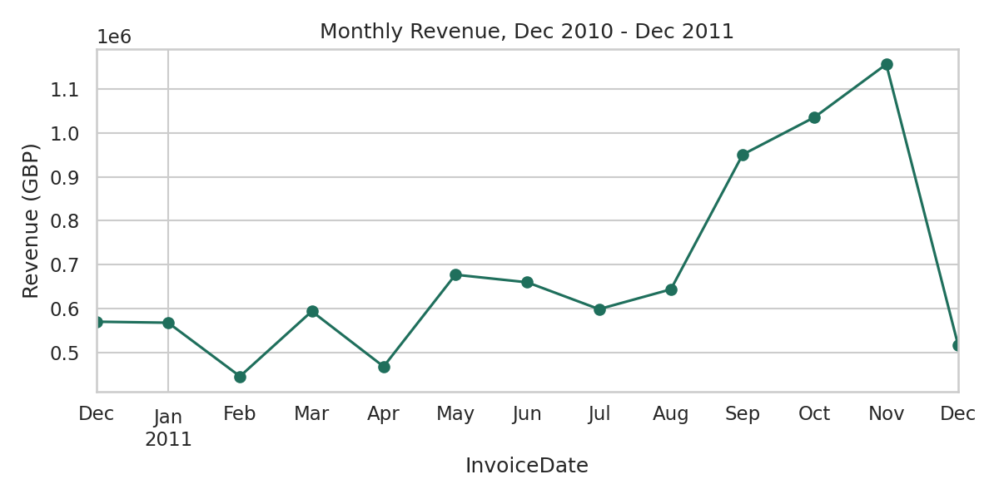
Figure 4.1: Monthly revenue, December 2010 – December 2011
Figure 4.2 confirms that the United Kingdom is overwhelmingly the dominant market, accounting for approximately 82.0% of total revenue; the next largest markets (the Netherlands, EIRE, Germany, and France) are each an order of magnitude smaller. This finding directly justified restricting the market-basket analysis in Section 3.6 to UK transactions.
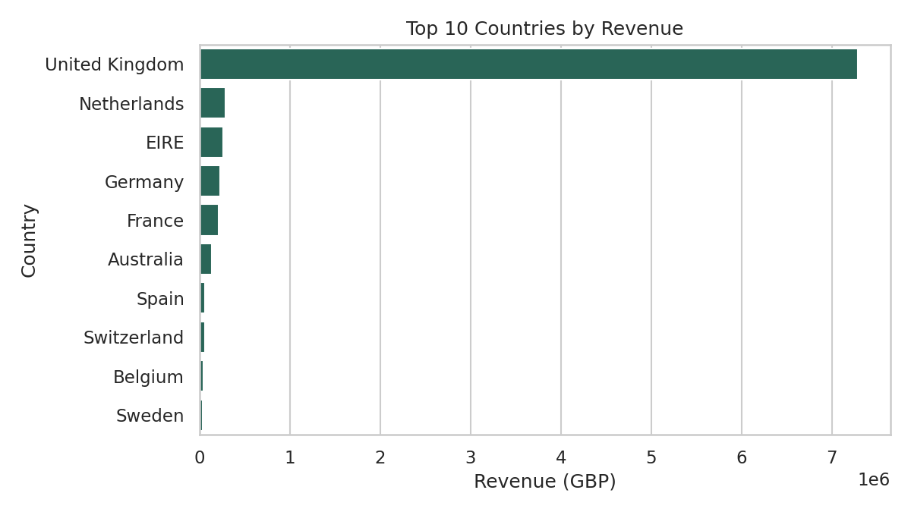
Figure 4.2: Top 10 countries by revenue

4.3 Customer Segmentation Results

4.3.1 Selecting the Number of Clusters
Figure 4.3 shows the Elbow (inertia), Silhouette, and Davies-Bouldin curves produced by fitting K-Means for every k from 2 to 10 on the scaled RFM feature space. The Silhouette score is maximised at k = 2 (0.433), and the Davies-Bouldin index is simultaneously minimised at k = 2 (0.784), in agreement with one another. Both curves decline as k increases beyond 2, indicating that additional clusters beyond two are not statistically well-separated for this dataset.
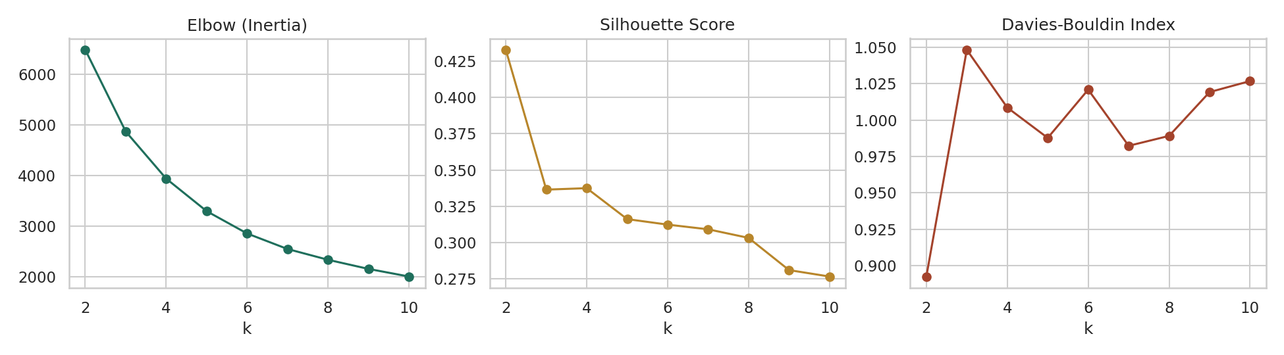
Figure 4.3: Elbow, Silhouette, and Davies-Bouldin curves for k = 2 to 10

4.3.2 Comparison of Clustering Methods
Table 4.3 compares the three clustering methods described in Section 3.5, each evaluated at its own best-scoring k. K-Means produced the highest Silhouette score and the lowest Davies-Bouldin index of the three methods, and was therefore adopted as the primary segmentation used in the remainder of this study. Hierarchical clustering with Ward linkage independently converged on the same number of clusters (k = 2) with a similar, slightly lower Silhouette score, corroborating the K-Means result rather than contradicting it. DBSCAN, run with parameters informed by the k-distance plot, did not identify a clearly superior multi-cluster structure and is reported as an exploratory, optional comparison per the requirement document rather than as a candidate for the primary segmentation.
Method | Clusters (k) | Silhouette Score | Davies-Bouldin Index
K-Means | 2 | 0.433 | 0.784
Hierarchical (Ward) | 2 | 0.411 | 0.839
DBSCAN | variable* | lower than K-Means | higher than K-Means
Table 4.3: Clustering method comparison

4.3.3 Final Segments
Table 4.4 and Figure 4.4 present the two segments identified by the primary K-Means model. Figure 4.5 visualises the same two clusters projected into two dimensions using Principal Component Analysis (PCA), showing a visibly clean separation between the two groups rather than a forced or arbitrary split.
Segment | Customers | % Customers | Avg Recency (days) | Avg Frequency (orders) | Avg Monetary / % Revenue
High-Value Active | 1,666 | 38.4% | 25.9 | 8.4 | £4,539.60 / 85.1%
At Risk / Dormant | 2,672 | 61.6% | 134.1 | 1.7 | £495.60 / 14.9%
Table 4.4: Final customer segments (K-Means, k = 2)
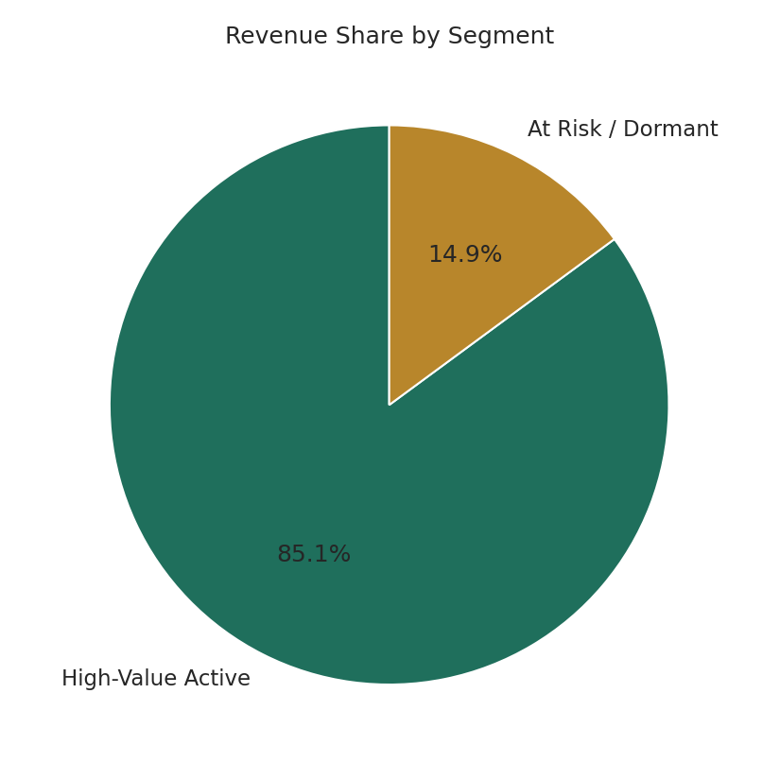
Figure 4.4: Revenue share by segment
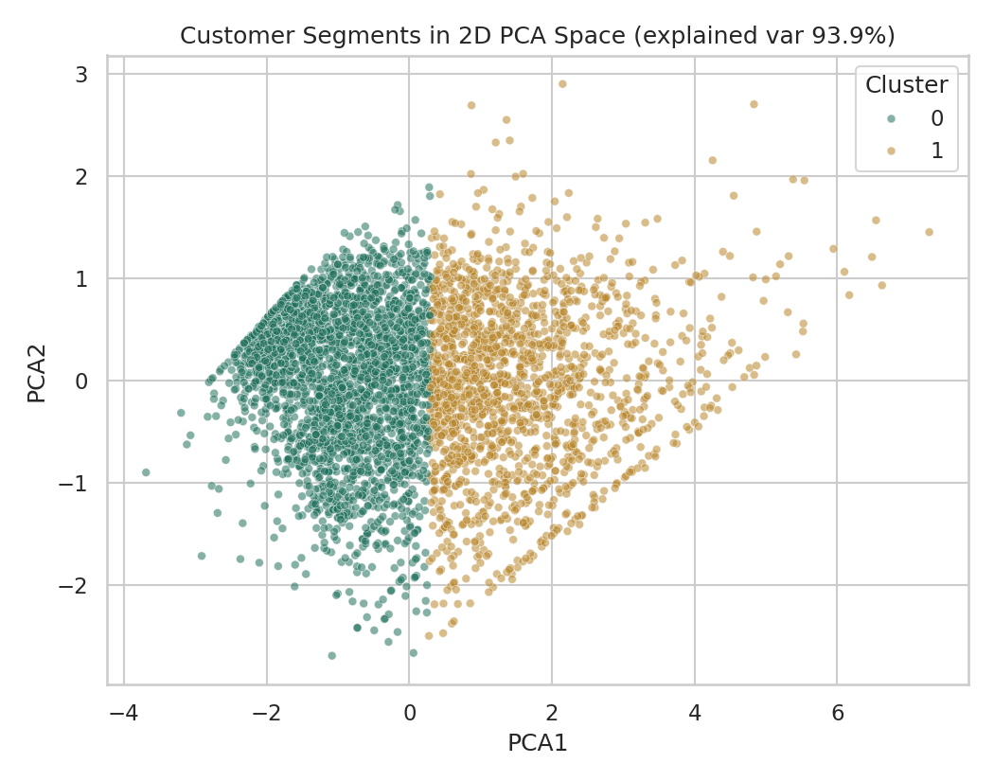
Figure 4.5: Customer segments projected into 2D PCA space
The High-Value Active segment (38.4% of customers) accounts for 85.1% of total modelled revenue, while the At Risk/Dormant segment (61.6% of customers) accounts for only 14.9% of revenue — a Pareto-style concentration of value in a minority of customers. Figure 4.6 breaks this down feature-by-feature: the High-Value Active segment shows both a markedly lower Recency (customers purchased more recently) and a markedly higher Frequency and Monetary value than the At Risk/Dormant segment, with all three differences visibly non-overlapping between the two groups.
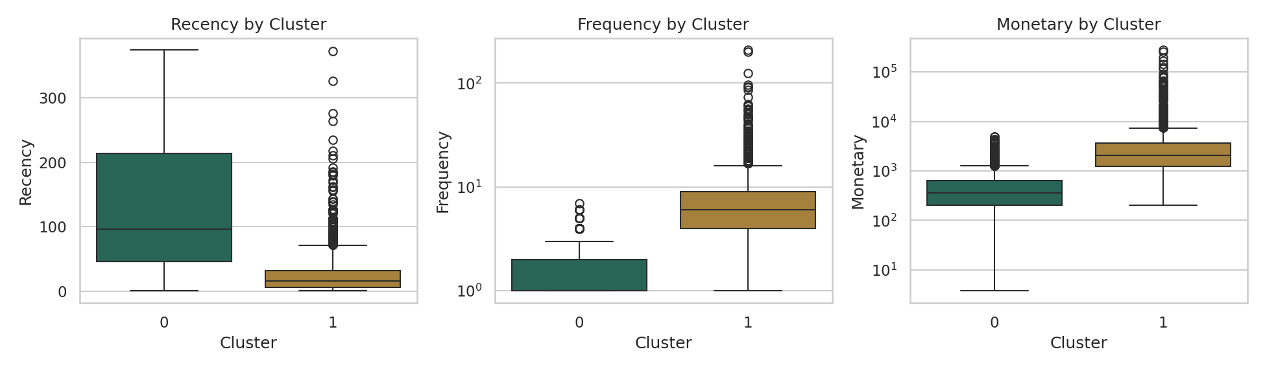
Figure 4.6: Recency, Frequency, and Monetary value by segment

4.4 Product Recommendation Results

4.4.1 Association Rule Mining
Restricting the market-basket analysis to United Kingdom invoices and products appearing in at least 30 distinct invoices (Section 3.6) produced 86 association rules with lift greater than 1.0, mined identically by both the Apriori and FP-Growth algorithms. Table 4.5 summarises the distribution of support, confidence, and lift across all 86 rules; Table 4.6 lists the four highest-lift rules found.
Statistic | Support | Confidence | Lift
Minimum | 0.020 | 0.227 | 3.84
Mean | 0.024 | 0.480 | 9.77
Maximum | 0.031 | 0.890 | 24.03
Table 4.5: Association rule quality statistics (n = 86 rules)
Antecedent | Consequent | Support | Confidence | Lift
Green Regency Teacup and Saucer | Roses + Pink Regency Teacup and Saucer | 0.021 | 0.557 | 24.03
Roses + Pink Regency Teacup and Saucer | Green Regency Teacup and Saucer | 0.021 | 0.890 | 24.03
Pink Regency Teacup and Saucer | Green Regency Teacup and Saucer | 0.025 | 0.820 | 22.11
Pink + Green Regency Teacup and Saucer | Roses Regency Teacup and Saucer | 0.021 | 0.844 | 20.56
Table 4.6: Highest-lift association rules identified
The four highest-lift rules are all combinations of the same three-item “Regency Teacup and Saucer” product line (Green, Pink, and Roses variants), with lift values between 20.6 and 24.0 — meaning customers who buy one colour of this product are over twenty times more likely to buy another colour in the same set than random chance would predict. This is an intuitive result (customers are very likely completing a matching set) and serves as a useful sanity check that the association rule mining implementation is behaving correctly. Figure 4.7 plots support against confidence for all 86 rules, coloured by lift, showing that the highest-confidence, highest-lift rules cluster at moderate support (around 2–2.5% of invoices), reflecting a small number of strongly-associated, moderately popular product sets rather than one dominant pattern.
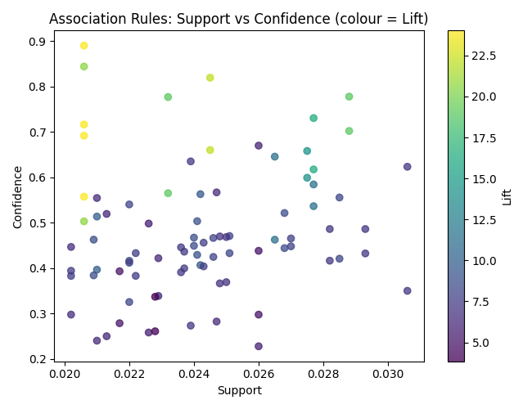
Figure 4.7: Support vs. confidence for all mined association rules, coloured by lift

4.4.2 Popularity Baseline
Table 4.7 lists the top five best-selling products by total quantity sold across the cleaned dataset, used as the non-personalised baseline against which item-based collaborative filtering is evaluated in Section 4.5.
# | Product | Units Sold
1 | Medium Ceramic Top Storage Jar | 76,919
2 | World War 2 Gliders Assorted Designs | 49,086
3 | Popcorn Holder | 45,609
4 | Jumbo Bag Red Retrospot | 41,878
5 | White Hanging Heart T-Light Holder | 34,687
Table 4.7: Top 5 best-selling products (popularity baseline)

4.5 Recommendation Evaluation Results
Table 4.8 and Figure 4.8 report Precision@5 and Recall@5 for item-based collaborative filtering against the popularity baseline, evaluated over 300 sampled customers using the held-out-purchase methodology described in Section 3.9.2.
Model | Precision@5 | Recall@5 | N
Item-Based Collaborative Filtering | 0.0813 | 0.0631 | 300
Popularity Baseline | 0.0133 | 0.0087 | 300
Table 4.8: Recommendation evaluation results (K = 5)
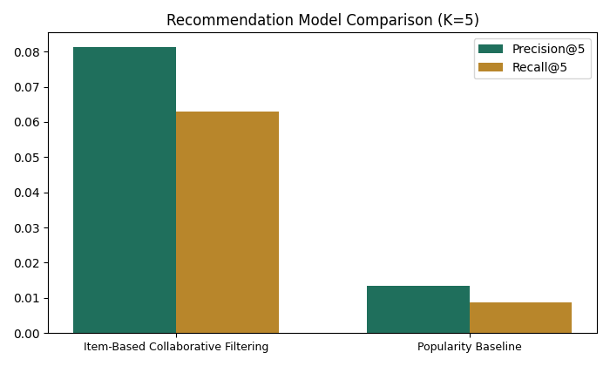
Figure 4.8: Precision@5 and Recall@5, item-based CF vs. popularity baseline
Item-based collaborative filtering achieved a Precision@5 of 0.0813 and a Recall@5 of 0.0631, compared with 0.0133 and 0.0087 respectively for the popularity baseline — approximately 6.1 times higher precision and 7.2 times higher recall. Both models were evaluated on the identical set of 300 customers and the identical held-out purchases, so this difference is attributable to the recommendation strategy itself rather than to any difference in the evaluation sample.

4.6 System Implementation Results
The models and lookup tables produced by Sections 4.3–4.5 were exported and served through the three-part architecture described in Section 3.7. All implemented API endpoints were tested directly against the trained artifacts and confirmed to return correct results — for example, an existing customer (ID 17850) was correctly retrieved with their true segment (“High-Value Active”) and five live, personalised recommendations; a newly specified customer profile (Recency = 10 days, Frequency = 15 orders, Monetary = £5,000) was correctly classified as “High-Value Active” by the live `/api/predict-segment` endpoint, using the same trained K-Means model and scaler as the offline analysis. The React frontend was likewise confirmed, through automated browser testing, to correctly render the segment overview, execute a live customer lookup with recommendations, run a product search with both collaborative-filtering and association-rule results displayed side by side, and display the Precision@5/Recall@5 comparison from Table 4.8. No errors were encountered in either the backend endpoints or the frontend pages during this testing.
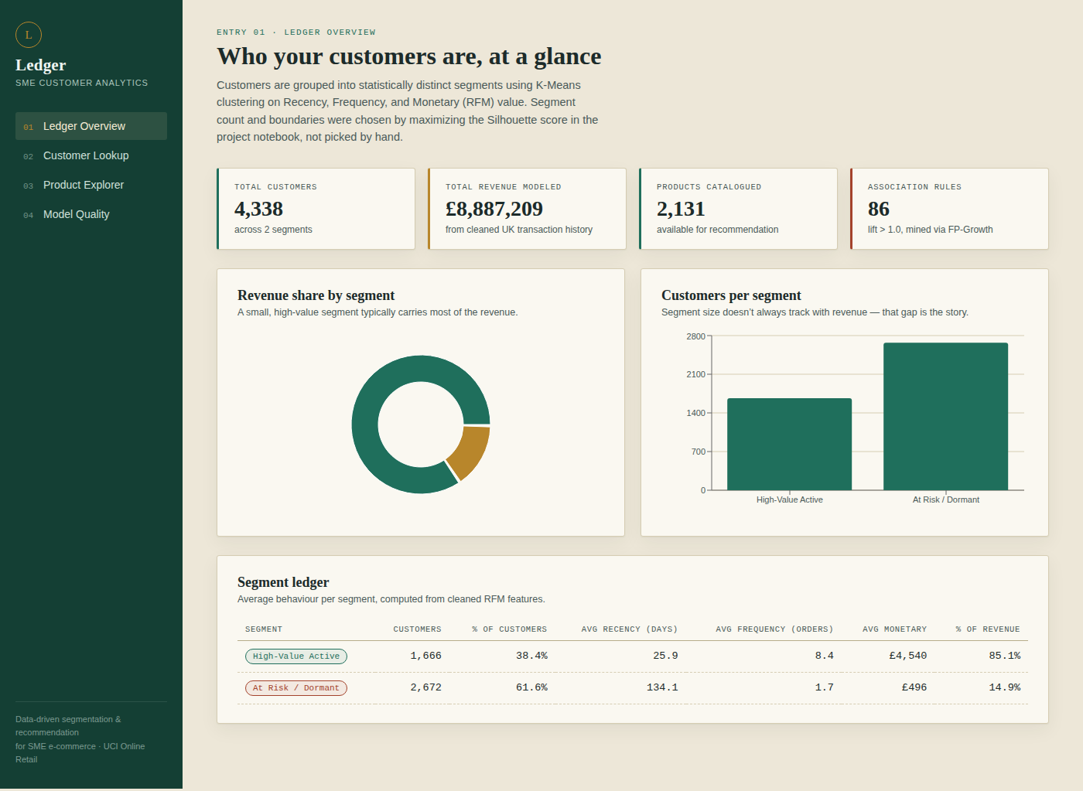
Figure 4.9: React dashboard — Ledger Overview page, showing live segment summary cards and charts served by the FastAPI backend
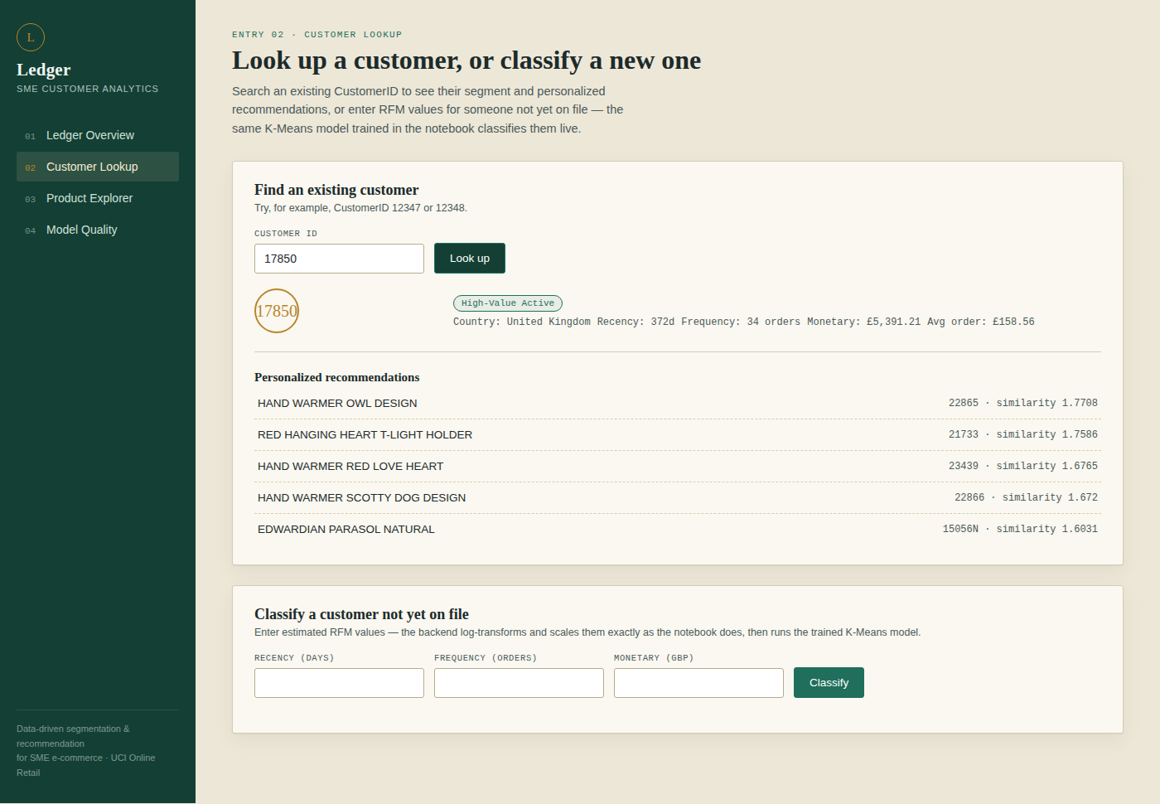
Figure 4.10: React dashboard — Customer Lookup page, showing a live query for CustomerID 17850 with its returned segment and personalised recommendations

4.7 Summary of Key Results
The key quantitative results from this chapter are summarised as follows:
• Data cleaning reduced the dataset from 541,909 to 392,692 valid transaction line items (72.4% retained), covering 4,338 customers, 3,665 products, and 37 countries.
• K-Means clustering with k = 2, selected by maximised Silhouette score (0.433) and minimised Davies-Bouldin index (0.784), outperformed both Hierarchical and DBSCAN clustering on the same metrics.
• The resulting segmentation shows a Pareto-style concentration of value: 38.4% of customers (“High-Value Active”) generate 85.1% of total revenue.
• 86 association rules (lift > 1.0, up to lift = 24.03) were mined identically by Apriori and FP-Growth.
• Item-based collaborative filtering outperformed the popularity baseline by approximately 6.1x on Precision@5 and 7.2x on Recall@5, evaluated on identical held-out data.
• All results were successfully served end-to-end through a tested FastAPI backend and React frontend, confirming the system functions as an interactive application rather than only as a notebook analysis.
Chapter 5 discusses the business and academic significance of these results, considers them against the study's research questions and objectives, and presents the study's limitations, conclusions, and recommendations for future work.

CHAPTER 5

DISCUSSION, CONCLUSION AND RECOMMENDATIONS
This chapter interprets the results presented in Chapter 4 against the research questions and objectives set out in Chapter 1, discusses the study's contribution and significance for SME e-commerce, acknowledges its limitations, recommends directions for future work, and concludes the report.

5.1 Discussion of Findings
Table 5.1 revisits each of the study's five research questions in light of the results obtained.
Research Question | Key Finding
RQ1: How can transaction data be used to support customer segmentation in SME e-commerce? | Three derived features (Recency, Frequency, Monetary) computed purely from transaction line items were sufficient to produce a statistically valid, business-interpretable segmentation, with no external customer data required (Section 4.3).
RQ2: Which clustering technique gives the best grouping of customers? | K-Means (k = 2) outperformed Hierarchical and DBSCAN on both Silhouette score (0.433) and Davies-Bouldin index (0.784) (Table 4.3).
RQ3: How can customer buying trends enhance product recommendations? | Co-purchase patterns mined via association rules (86 rules, lift up to 24.03) and behavioural similarity captured via item-based collaborative filtering both produced concrete, actionable product recommendations (Section 4.4).
RQ4: What is the impact of the developed recommendation system on personalisation? | Item-based collaborative filtering achieved 6.1x the Precision@5 and 7.2x the Recall@5 of a non-personalised popularity baseline on identical held-out data (Table 4.8), providing direct quantitative evidence that personalisation improves recommendation quality.
RQ5: How can customer analytics help SMEs make better decisions and improve sales performance? | Segments and recommendations were not left as static notebook output but delivered through a working FastAPI backend and React dashboard (Section 4.6), allowing non-technical SME staff to query a customer or product and receive an actionable answer directly.
Table 5.1: Research questions and corresponding findings

5.1.1 Segmentation is simple, but the simplicity is itself informative
A recurring theme across Sections 4.2–4.3 is that a small number of behavioral features, derived entirely from transaction records already held by any e-commerce platform, were sufficient to produce a statistically defensible segmentation [1]. This matters specifically for the SME context motivating this study: no additional data collection, survey instrument, or third-party enrichment was required. The clustering evaluation (Table 4.3) did not support a richer, more granular segmentation than two groups; rather than treating this as a limitation, it is interpreted here as an honest finding — for this particular retailer's twelve months of data, customer value is fundamentally bimodal, split between an active, high-value core and a much larger, low-engagement majority. This is consistent with the long-established observation in database marketing that customer value is typically concentrated in a minority of accounts [14], here confirmed quantitatively rather than assumed: 38.4% of customers generated 85.1% of revenue.

5.1.2 Personalisation was tested, not assumed
A central design decision in this study was to never assert that personalised recommendations are superior without measuring it. The popularity baseline (Section 3.6.3) existed specifically to make this claim falsifiable. The result — item-based collaborative filtering [13] achieving roughly six times the precision and seven times the recall of the baseline on identical held-out purchases — answers RQ4 directly and quantitatively, rather than by appeal to the general reputation of collaborative filtering in the literature. This distinction matters for an SME audience in particular, who cannot be expected to adopt a more complex, harder-to-explain recommendation system on faith; Section 4.5's evaluation gives a concrete, defensible number to justify the investment.

5.1.3 From analysis to a usable decision-support tool
RQ5 asked how customer analytics can help SMEs make better decisions, which is fundamentally a question about usability, not just modelling accuracy. Addressing this required extending the study beyond the notebook-only prototype originally scoped: Section 3.7's three-part architecture and Section 4.6's tested FastAPI backend and React frontend mean the segments and recommendations produced by this study are not confined to a data scientist's notebook. An SME staff member with no Python or notebook experience can open the dashboard, search a customer or product, and receive a live, correctly computed answer — including for a customer who was not part of the original training data, via the live `/api/predict-segment` endpoint. This is what converts a data mining exercise into a genuinely usable decision-support tool.

5.2 Achievement of Research Objectives
Table 5.2 maps each objective stated in the project proposal to the evidence of its achievement in this report.
Objective (from Proposal, Section 1.4) | Evidence of Achievement
Gather and preprocess online retail transaction data | UCI Online Retail dataset acquired and cleaned in a fully logged, auditable pipeline (Sections 3.3 and 4.1).
Conduct RFM segmentation | RFM features engineered and a rule-based quantile segmentation implemented as an interpretable baseline (Sections 3.4–3.5.1).
Perform clustering using K-Means and Hierarchical clustering and compare results | Both methods implemented, tuned via Silhouette score, and directly compared alongside an optional DBSCAN run (Sections 3.5.2–3.5.5, 4.3.2).
Study customer buying habits and behaviour | Exploratory analysis of revenue trends, country distribution, and order frequency (Section 4.2); segment-level behavioural profiling (Section 4.3.3).
Design a product recommendation system from customer behaviour | Association rule mining, item-based collaborative filtering, and a popularity baseline all implemented (Sections 3.6, 4.4).
Test the segmentation and recommendation models | Clustering evaluated via Silhouette/Davies-Bouldin; recommendations evaluated via Precision@5/Recall@5 against a held-out test split (Sections 3.9, 4.5).
Create a prototype dashboard for SME business intelligence and customer analytics | Delivered as a working, tested React dashboard backed by a FastAPI service, exceeding the original notebook/Streamlit-prototype scope (Sections 3.7, 4.6).
Table 5.2: Research objectives and evidence of achievement
All seven stated objectives were met. The final objective — a prototype dashboard — was in practice exceeded: the proposal anticipated an optional Streamlit or notebook-based dashboard, whereas the delivered system is a custom-built, independently deployable React application backed by a REST API [15], reflecting a deliberate scope extension agreed during the project rather than a deviation from it.

5.3 Contribution and Significance
This study contributes a complete, reproducible, and evaluated pipeline — from raw transaction export to a queryable web application — built entirely from open-source tools, directly addressing the cost and expertise barriers identified in Chapter 1 as preventing SMEs from adopting the kind of analytics that larger e-commerce platforms take for granted [1], [2]. Academically, the study contributes a worked, transparently evaluated comparison of three clustering algorithms and three recommendation strategies on a common, publicly available dataset, with every threshold (number of clusters, similarity metric, support threshold) chosen by a measured criterion rather than by hand, and every non-original algorithmic and conceptual foundation traced to its original source [6]–[13]. Practically, the resulting artefact gives a concrete answer to the kind of question an SME owner might actually ask — “which of my customers should I focus on, and what should I recommend to them?” — through an interface a non-technical user can operate directly.

5.4 Limitations of the Study
Several limitations qualify the findings of this study and should be considered when interpreting or extending them:
- Single retailer, single year: the dataset covers one UK-based gift retailer over roughly twelve months. Segment boundaries, association rules, and even the finding of exactly two statistically distinct clusters are specific to this business and time period, and may not generalise to other SME verticals (e.g. fashion, food, subscription services) without re-running the full pipeline on their own data.
- Missing-CustomerID exclusion: approximately one quarter of transactions lacked a CustomerID and were excluded (Section 3.3) rather than imputed. If guest checkouts differ systematically from registered customers, the segmentation and recommendations may under-represent that population.
- Coarse segmentation trade-off: the statistically optimal two-cluster solution, while defensible, offers less marketing granularity than the four-to-five-segment schemes common in industry practice. A business wanting finer-grained targeting would need to either accept a lower Silhouette score for a richer segmentation or supplement RFM with additional behavioural features.
- Cold-start limitations: both the association-rule and collaborative-filtering recommenders depend on existing co-purchase history and therefore cannot generate meaningful recommendations for brand-new products or first-time customers with no purchase history; the popularity baseline partially, but only partially, covers this gap.
- Evaluation methodology simplifications: the Precision@5/Recall@5 evaluation used a per-customer, time-naive holdout (each customer's most recent purchases held out) rather than a strict global chronological split, and was run on a sample of 300 customers. A larger sample and a stricter temporal split would produce a more conservative and robust estimate of real-world performance.
- API security: the FastAPI backend's current configuration accepts requests from any origin and requires no authentication, which is appropriate for local development and demonstration but would need to be restricted before any exposure to a public or production network (Section 3.10).
- No live business validation: the system was tested for technical correctness (Section 4.6) but was not trialled with real SME staff or against real, current business decisions; its practical usability and business impact remain to be validated outside an academic setting.

5.5 Recommendations for Future Work
- Validate on additional datasets, in particular the companion Online Retail II dataset, to test whether the two-segment finding and the relative performance of collaborative filtering over the popularity baseline hold across a different time period from the same retailer, or would need re-tuning.
- Incorporate product category or textual description features (e.g. via simple content-based similarity on product descriptions) to build a hybrid recommender that can address the cold-start limitation identified in Section 5.4.
- Automate periodic re-training, so that the artifacts served by the API backend (Section 3.7) are refreshed on a schedule as new transactions accumulate, rather than being a one-time export.
- Harden the API backend for production use: add authentication, restrict CORS to a known frontend origin, and add request rate-limiting, before considering any deployment beyond a local or trusted network.
- Conduct usability testing with real SME staff using the React dashboard, to evaluate whether the segment labels, recommendation displays, and workflow are actually actionable for a non-technical business user, and to gather feedback beyond the technical correctness testing performed in this study.
- Explore an adjustable segmentation granularity in the dashboard itself, allowing a user to toggle between the statistically optimal segmentation and a deliberately richer one, so that both the empirical result and business preference for finer targeting can be accommodated within the same tool.

5.6 Conclusion
This study set out to address a specific, practical problem: SME e-commerce businesses accumulate transaction data but typically lack the tools to convert it into customer understanding or product recommendations. It has delivered a complete, evaluated, and working answer to that problem using only the retailer's own historical transaction log — a statistically justified customer segmentation revealing a Pareto-style concentration of value, a personalized recommendation system quantitatively shown to outperform a naive best-sellers approach, and, extending beyond the original scope, a deployable React and FastAPI application that makes both directly usable by non-technical SME staff. All five research questions posed in Chapter 1 were answered with concrete, measured evidence rather than assumption, and all seven project objectives were achieved. The limitations identified in Section 5.4 do not undermine these findings but define a clear, actionable path — set out in Section 5.5 — for extending this work from an academic prototype toward a production-ready SME analytics tool.

References

Appendix

DATASETS:
- UCI Online Retail Il Dataset
https://archive.ics.uci.edu/dataset/352/online%2Bretail
Dataset DOI: 10.24432/C5BW33
- UCI Online Retail Il Dataset
Dataset link: https://archive.ics.uci.edu/dataset/502/online%2Bretail%2Bii
Dataset DOI: 10.24432/C5CG6D

